Vertical Orientation

Definition
# Source: AI Source: Provided by: [Data Path: Persons Table -> ID Column: 1, Name_En Column: Motasem Essam] -> From: [ChatGPT] on [7/20/2026]
Vertical Orientation is the arrangement of an object so that it is parallel to the vertical reference line or the y-axis. In this orientation, the object extends from top to bottom rather than from left to right.
Vertical orientation is commonly used in geometry, engineering, architecture, technical drawing, construction, surveying, computer graphics, and design.

Characteristics
# Source: AI Source: Provided by: [Data Path: Persons Table -> ID Column: 1, Name_En Column: Motasem Essam] -> From: [ChatGPT] on [7/20/2026]
A vertically oriented object:
- Extends from top to bottom.
- Is parallel to the vertical axis.
- Is perpendicular to the horizontal axis.
- Does not necessarily indicate movement; it only describes alignment.
- Represents the direction of height.

Illustration
# Source: AI Source: Provided by: [Data Path: Persons Table -> ID Column: 1, Name_En Column: Motasem Essam] -> From: [ChatGPT] on [7/20/2026]
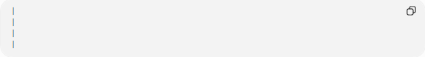
│
│
│
│

Vertical Line
# Source: AI Source: Provided by: [Data Path: Persons Table -> ID Column: 1, Name_En Column: Motasem Essam] -> From: [ChatGPT] on [7/20/2026]
A vertical line has:
- Constant horizontal position.
- Undefined slope.
Equation:
$$x=c$$
where:
- $c$is a constant.
Example:
$$x=4$$

Examples
# Source: AI Source: Provided by: [Data Path: Persons Table -> ID Column: 1, Name_En Column: Motasem Essam] -> From: [ChatGPT] on [7/20/2026]
Vertical orientation can be observed in:
- A flagpole
- A building wall
- A tree trunk
- A door standing upright
- A standing ruler
- A portrait-oriented computer monitor
- An elevator shaft

Measurement
# Source: AI Source: Provided by: [Data Path: Persons Table -> ID Column: 1, Name_En Column: Motasem Essam] -> From: [ChatGPT] on [7/20/2026]
Vertical orientation is commonly measured relative to the horizontal axis.
Typical orientation angles:
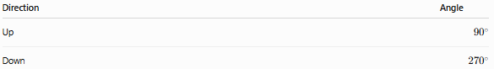
Direction | Angle
Up | $${90}^{∘}$$
Down | $${270}^{∘}$$

Applications
# Source: AI Source: Provided by: [Data Path: Persons Table -> ID Column: 1, Name_En Column: Motasem Essam] -> From: [ChatGPT] on [7/20/2026]
Vertical orientation is used in:
- Geometry
- Engineering drawings
- Architecture
- Construction
- CAD (Computer-Aided Design)
- Computer graphics
- Surveying
- Interior design
- Manufacturing
- Structural engineering

Advantages
# Source: AI Source: Provided by: [Data Path: Persons Table -> ID Column: 1, Name_En Column: Motasem Essam] -> From: [ChatGPT] on [7/20/2026]
Vertical orientation:
- Represents height and elevation.
- Supports structural design.
- Simplifies technical drawings.
- Provides a standard reference direction.
- Assists accurate alignment during construction and manufacturing.

Limitations
# Source: AI Source: Provided by: [Data Path: Persons Table -> ID Column: 1, Name_En Column: Motasem Essam] -> From: [ChatGPT] on [7/20/2026]
Vertical orientation:
- Depends on the chosen reference frame.
- May appear different if the observer or coordinate system is rotated.

Comparison with Other Orientations
# Source: AI Source: Provided by: [Data Path: Persons Table -> ID Column: 1, Name_En Column: Motasem Essam] -> From: [ChatGPT] on [7/20/2026]
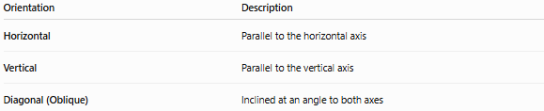
Orientation | Description
Horizontal | Parallel to the horizontal axis
Vertical | Parallel to the vertical axis
Diagonal (Oblique) | Inclined at an angle to both axes

Key Points
# Source: AI Source: Provided by: [Data Path: Persons Table -> ID Column: 1, Name_En Column: Motasem Essam] -> From: [ChatGPT] on [7/20/2026]
- Vertical Orientation means an object is aligned top to bottom.
- It is parallel to the vertical (y) axis.
- A vertical line has:
  - Constant xxx-value
  - Undefined slope
- Vertical orientation is widely used in geometry, engineering, architecture, surveying, CAD, and construction.

Conclusion
# Source: AI Source: Provided by: [Data Path: Persons Table -> ID Column: 1, Name_En Column: Motasem Essam] -> From: [ChatGPT] on [7/20/2026]
Vertical Orientation describes the alignment of an object parallel to the vertical reference axis, extending from top to bottom. It is a fundamental concept used to represent height, elevation, and upright positioning. Vertical orientation plays an essential role in geometry, engineering, architecture, construction, surveying, computer graphics, and technical drawing, where accurate alignment and structural positioning are required.

